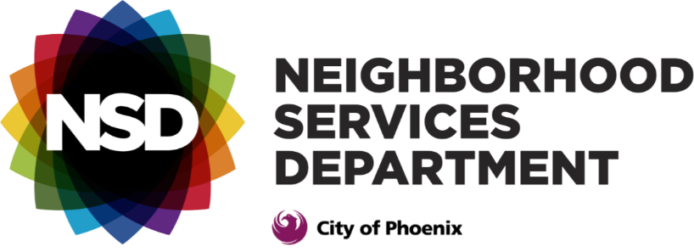

Love Your Block program
And
LOVE YOUR BLOCK GRANTS INFORMATIoN
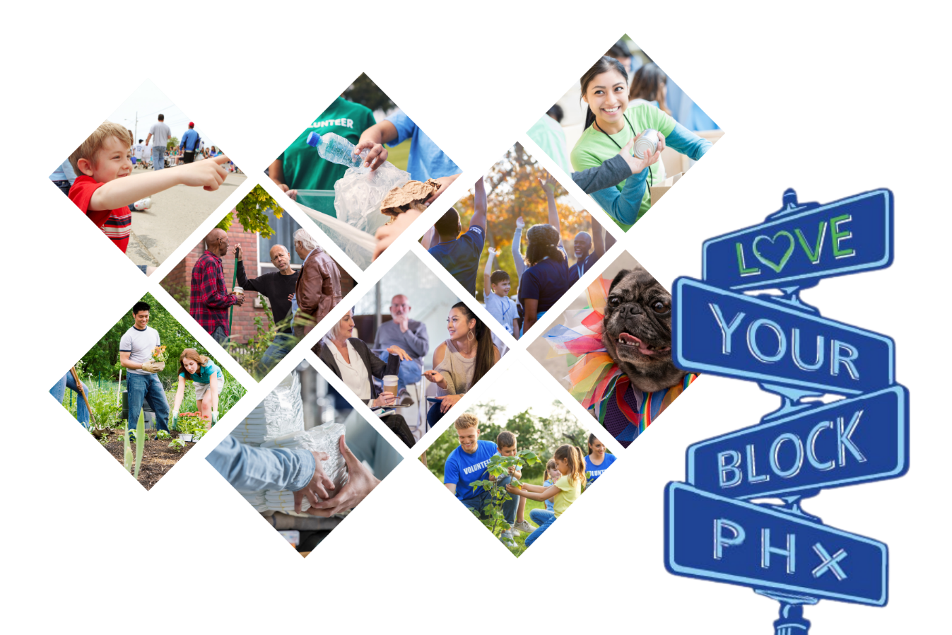

In partnership with the
Gila River Indian Community
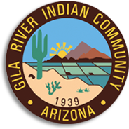
Love Your Block PROGRAM
The Love Your Block (LYB) program, administered by the City of Phoenix Neighborhood Services Department (NSD), is for neighborhood groups and/or block watch groups interested in making a difference in their community. The program is designed to improve neighborhoods and increase civic engagement, with technical assistance and grant funding opportunities from NSD and its partners. LYB offers instructor-led workshops designed to provide pertinent information, resources and engagement skills to neighborhood residents, that result in collaborations and partnerships that could bring a positive impact to their respective communities.

The goals of the LYB Program are:
- To reduce blight and beautify neighborhoods.
- Engage current and new stakeholders willing to participate in neighborhood improvement efforts.
- Build neighborhood capacity by implementing a sustainable project with a positive impact.
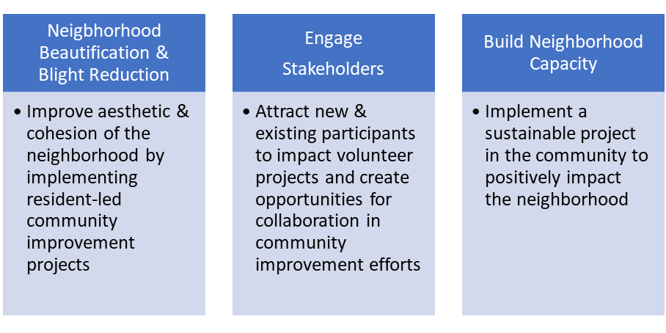
Awarding grants is one opportunity the LYB Program offers that makes these goals achievable. Neighborhood and block watch groups that meet the eligibility requirements and are listed on Neighborhood LINK, are encouraged to apply for grants up to $5,000, to implement a sustainable project in their community.
Grant awardees will be responsible for managing the completion of their proposed projects by the deadline, as well as researching and selecting business partners or vendors who will provide services to complete their project at a reasonable cost. Grantees are encouraged to identify local businesses who are invested in the success of the community.
LYB GRANT APPLICATION REQUIREMENTS
- Be an active neighborhood group that has been listed with NSD’s Neighborhood LINK since January 2024, at a minimum.
- Must propose a project scope and budget that will benefit the neighborhood/community and be accessible to its residents. Proposal must include a maintenance plan for the proposed project, if applicable
- Must have a minimum of three neighborhood group members involved with the proposed project.
- Must demonstrate the ability to complete the project within six months (extensions may be granted at the discretion of the LYB Program Administrator).
- If the proposed project site is on private property, applicant must submit a written letter of permission from the property owner, along with the completed application.
- A completed application must be received by the due date, 5 p.m. Monday, April 15, 2024.
- If awarded, applicants must be able to attend the LYB mandatory workshop on Saturday, May 11, 2024, along with three to six other members of the neighborhood group.

Previous grant awardees are not eligible to apply for the grant within a three-year period.

LYB grant application review process will be managed by the LYB manager and scored by a review committee made up of city staff and community leaders (who are not applying for the grant). The proposal with the highest score from each City Council district will be awarded a LYB grant. A total of eight grants, up to $5,000 each, will be awarded. If there is no application/proposal received from a city council district, the applicant with the next overall highest score will be awarded the LYB grant.

LYB GRANT AWARDEE REQUIREMENTS
- As part of the leadership development, neighborhood groups receiving LYB grants are encouraged to manage and lead their own projects. Groups are responsible for developing their project scope, managing their budget and implementing their project.
- Awardees must research and identify vendors for their project and submit estimated price quotes along with the application.
- Awardees must submit invoices for each expense identified in their project budget tobe paid directly by LYB staff. Invoices should reflect the most reasonable price the group was able to find to stay within budget.
- Funds will only be disbursed for a current invoice from the vendor that includes a unique invoice number, date, and total. Invoices should be sent to the LYB email with a brief note explaining what the invoice is for.
- In addition to LYB staff, grant awardees may work with their area Neighborhood Specialist on how to request direct payment to their vendors for goods and services rendered. Specialists can assist in completing any necessary forms and ensuring that receipts and invoices have all been submitted in a timely manner. Awardees may submit their finalized project scope, budget and documentation of invoices or estimates to their area Neighborhood Specialist, which in turn will need approval from the LYB Administrator and Deputy Neighborhood Engagement Director.To find your Neighborhood Specialist, refer to this page: phoenix.gov/nsd/programs/neighborhood-specialist
- Awardees may spend up to the amount awarded. The maximum amount that can be requested by a group is $5,000, inclusive of all taxes and fees.
USE OF GRANT FUNDS
- Funds may be used for marketing materials that promote or increase awareness of the neighborhood group’s identity, such as T-shirts, hats, newsletter development, flyers, and other materials for branding and engagement.
- Funds may be used to pay for services that support a proposed project, such as services rendered by a muralist or a streets barricade company for a street fair.
- Food and non-alcoholic beverages costs, included in the proposed project’s budget, must be no more than 5% of the project’s total budget (or total amount requested). Therefore, the projected cost for food and non-alcoholic beverages should be up to $250.
- Funds may be used for building materials needed for the project.
- Groups must spend the awarded funds by Sept. 13, 2024, which means all invoices and other documentation must be submitted to the LYB Administrator by 5 p.m. on Sept. 13, 2024 . Any remaining funds may not be available after this date or may not be eligible for an extension.
PROHIBITED USE OF GRANT FUNDS
- Administration of the grant itself.
- Projects on private property, including but not limited to landscaping, fencing, painting, etc. There may be exceptions to this rule. If the project site is on private property, applicants must include in their grant application a letter of permission from the property owner.
- The purchase of gift cards or gift certificates.
- Alcoholic beverages, including wine and beer.
- Awards and raffle prizes.
- Entrance or admission fees for any in-state or out-of-state non-educational field trips, including water and amusement parks.
- Out-of-state field trips or travel (educational or non-educational).
- Toward the rental or prurchase of motor vehicles.
PROJECT COMPLETION
Projects must be completed by Oct. 31, 2024, unless an extension has been granted in writing by the LYB manager. Upon completion of the project, groups must provide the following to the LYB manager:

- Photos of the project, during the development phase and completion phase, to be included in the final report that tells the group’s success story.
- Provide any metrics that demonstrate the efforts and the impact of the project in the community. Metrics may include:
  - Number of volunteers and volunteer hours.
  - Number of residents impacted by project.
  - If the project is a community cleanup, the tonnage of debris removed.
  - If the project is a community event, number of particpants or expected participants.
- Completed survey to help us understand your experience with the LYB process, as well as to help us improve it.
- All photos, metrics and narrative related to the neighborhood group’s project must submitted to the LYB Administrator by Nov. 8, 2024 or sooner.

EXAMPLE OF PAST PROJECTS
- Installation of street sign toppers for neighborhood identity awareness.
- Curb painting of house numbers for the neighborhood.
- Murals that reflect the neighborhood’s identity and beautification (will require written permission from owner of property regarding the use of the wall or building façade that will be painted.)
- Landscaping cleanup projects in the right-of-way to minimize blight and increase community engagement.
- Tree/shrub planting in the right-of way, (may require agreement between the City of Phoenix and the responsible party regarding proper maintenance of trees and shrubs).
- Creating dog/pet waste stations that encourage owners to pick up after their pets.
- Installation of a “little free library” for neighbrohood residents to share their literary favorites with each other and encourage reading.

Important Contact Information
LYB Program email: LoveYourBlock@phoenix.gov
LYB Manager: Ray Yocopis, ray.yocopis@phoenix.gov, 602-495-0116
LYB Coordinator (accounting): Ashley Henderson, ashley.henderson@phoenix.gov,
602-261-8109

To find your Neighbrohood Specialist: phoenix.gov/nsd/programs/neighborhood-specialist

Updated March 11, 2024

